**Part 1: Variables and Scope**

1. Explain how var works in JavaScript. What is variable hoisting? Give a code example.

Ans) Var is function scope . hoisting : use the variable before its declartion but the value will be undefined until the assignment

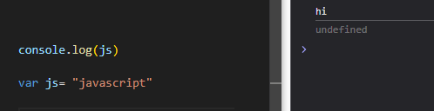

1. What is the scope of a variable declared with var inside a function? What about inside a block (e.g., an if statement)?

Ans) inside function is function scope .. inside block like if statement is global

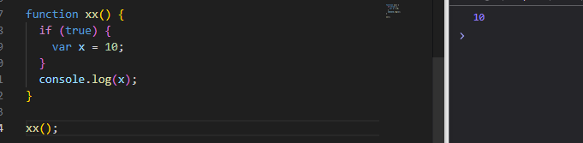

1. List all JavaScript primitive types in ES5. Give an example of each.

Ans) string – number – Boolean – undefined - null

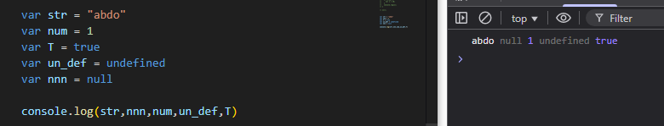

1. What is the difference between a primitive type and an object type? Give an example where this difference is important.

Ans) primitive like number ,string is valued ---- object like oject , array is refrence

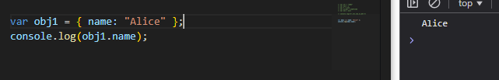

1. Create a number, string, and boolean using both literal and constructor syntax. Show the difference in their types using typeof.

Ans)

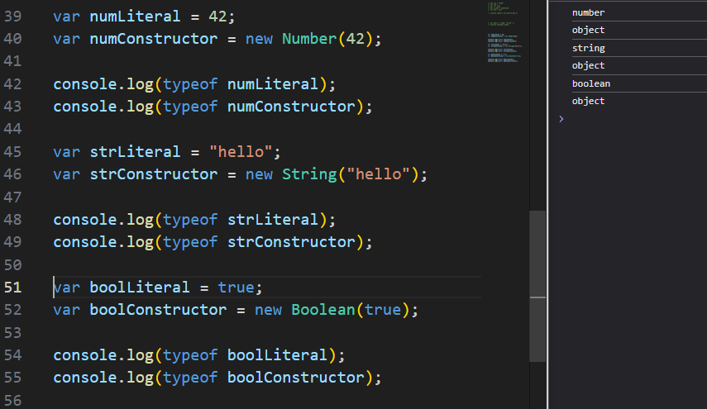

1. Why is it generally recommended to use literals instead of constructors for primitive types?

Ans) cleaner and faster for memory

7. Given the following code, what will be the output? Explain why.

var x = 123.4567;

console.log(x.toFixed(2));

console.log(x.toPrecision(4));

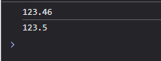

Ans)

to_Fixed() تحديد الارقام بعد العلامة بعد تحويل الرقم ل string

toPrecision() تحديد عدد الdigits الناتجة بعد تحويلها ل string

1. What is NaN? How can you check if a value is NaN? Give an example.

Ans) not number and its type is number to check it use isNaN()

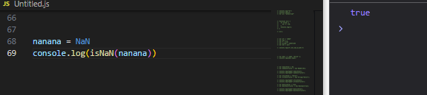

1. What is the difference between parseInt, parseFloat, and Number? Give an example for each.

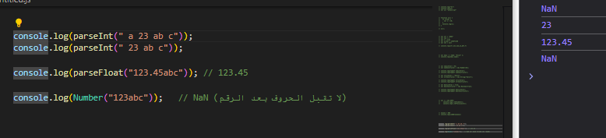Ans)

Parse_int : radix

Parse_float no radix

Number no radix

1. What is the difference between implicit and explicit type casting? Give an example of each.

Ans)

Implicit : تحويل تلقائي explicit تحويل صريح ب فانكشن

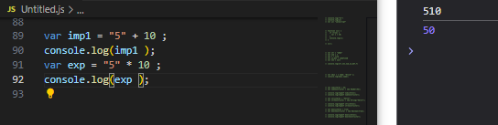

11. What will be the result and type of the following expressions? Explain your answer.

- true + 5 true =1 so 1+5 =6

- "10" – 2 implict casting 10-2 =8

- 12 - "1a" "1a" ليست سلسلة رقمية صالحة.

- 5 / 0 رياضيا infinite

- 5 + undefined undefined تتحول إلى NaN في العملية الحسابية

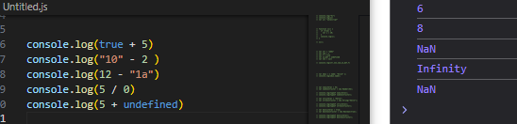

12. What will be logged to the console in the following code? Explain each step.

var a = "15.5";

var b = +a;

console.log(b, typeof b);

ans) first a is string

b make cast of a to number

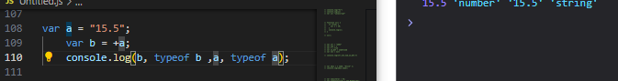

13. What will be the output of:

var result = 20 > true < 5 == 1;

console.log(result);

Explain why.

Ans) 20 > true is true and true is less than 5 is true and true equals to 1 so the final result is true

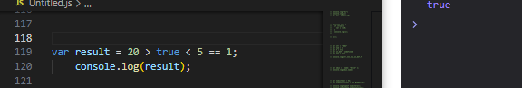

14. Write a function that takes a string and returns true if it can be converted to a valid number, and false otherwise.

Ans)

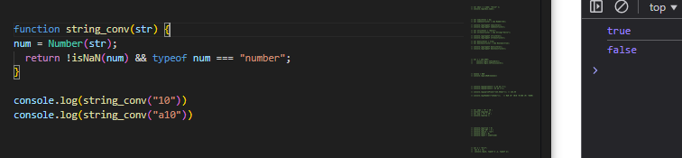

15. Write a program that prints all numbers from 1 to 20 using a while loop.

Ans)

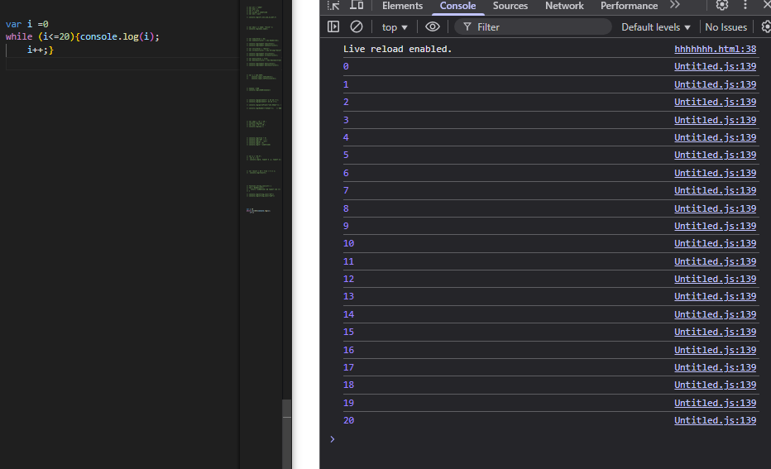

16. Write a program that asks the user to enter numbers until they enter 0, using a do...while loop. After the loop ends, print the sum of all entered numbers (excluding 0).

Ans)

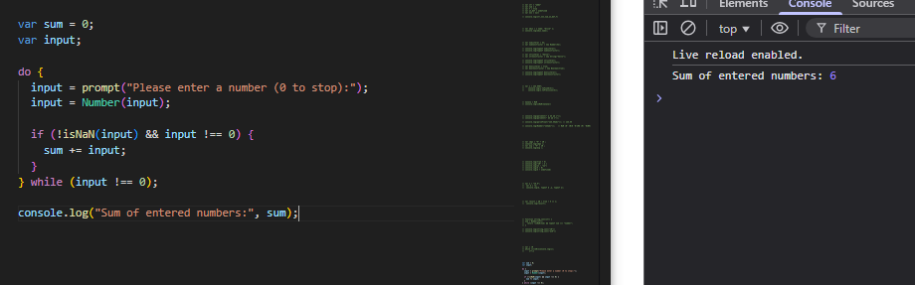

17. Write a program that takes a number from 1 to 7 and prints the corresponding day of the week using a switch statement. Use a for loop to test your program with all numbers from 1 to 7.

Ans)

